How to homework.ipynb – please check the whole document, some possible problems – exlplained

We recommend planning at least 1.5 h for the homework. Give it your full attention, understand what’s going on, don’t rush through it. Ask us questions. This helps you as well as us – to understand what has not been clearly delivered during the lecture. Questions are an important form of feedback.

If you plan to submit your homework, please do so by Monday 03.02, so that we have enough time to go over them.

Download the [homework link](https://github.com/danielparthier/schmitzlab_python/blob/main/homework/1_homework.ipynb)

* Go on the link 🡪 click the download symbol
* ! Place the homework in the same folder that you’ve worked in during the lesson
* ! DO NOT place the homework in the .venv folder

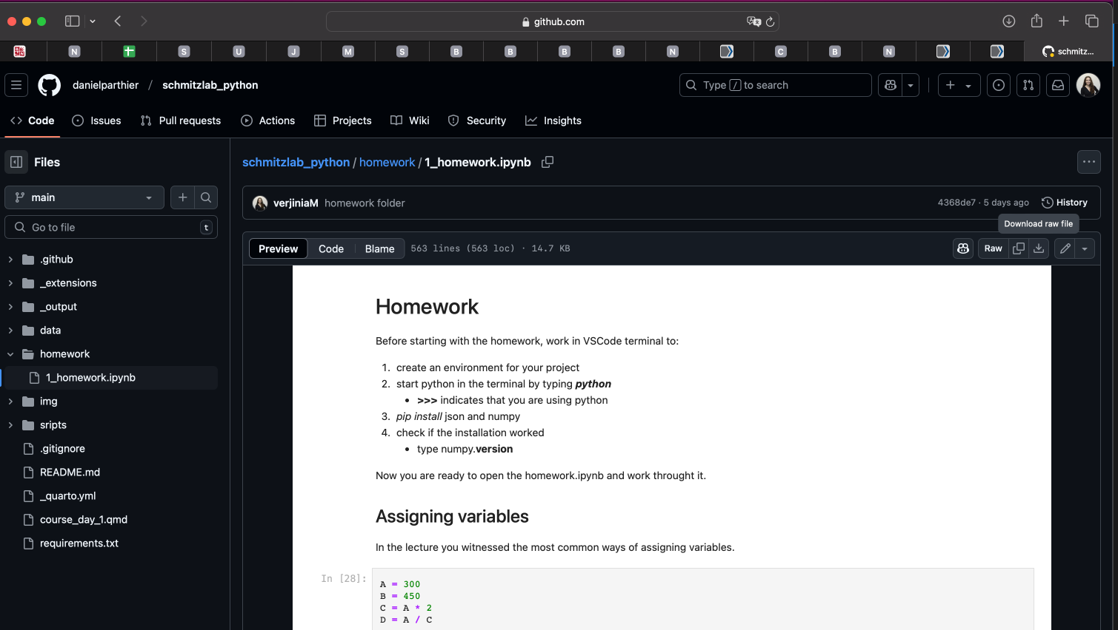

* Your VSCode setup should look something like this. Make sure that what’s in the red boxes, looks the same on your setup

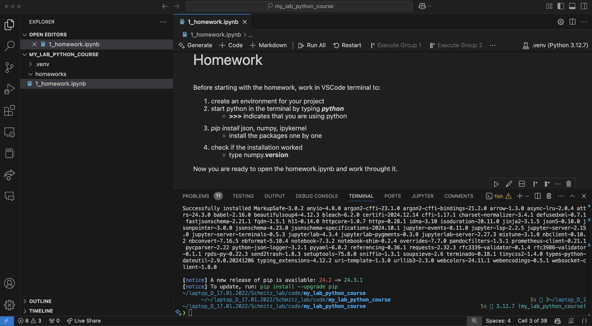

Command line indicating that you are using the correct environment

Tidy folder structure

1_homework.ipynb into the ‘homeworks/’ folder

Correct python interpreter

* In case you get a prompt to select the interpreter
  + Select **python environments 🡪 .venv**

* In case you get a message in the bottom right sbout python interpreter
  + Click **select python interpreter** 🡪 and then select your .venv from the list

* in case you are prompted to install a package by VSCode, do it
  + Click **install**
  + You might need to restart VSCode